The charts below show the changes in ownership of electrical appliances and amount of time spent doing housework and households in one country between 1920 and 2019.
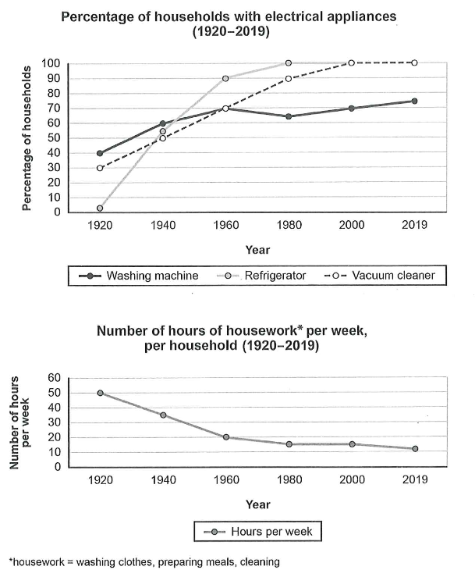
The provided graphs illustrate statistical insights related to the fluctuation in the ownership of electric home appliances and time spent doing housework and household chores in one specific country between 1920 and 2019.
Overall, it is evident that electronic devices have wielded influence on society. Consequently, the number of households dramatically skyrocketed, while the number of weekly hours gradually decreased within a particular time frame.
An analytical perspective highlights that vacuum cleaners reached 30% of households, vacuum cleaners capturing 40% of the domestic population; meanwhile, approximately 1.1% of households used refrigerators in 1920. The graph shows that refrigerators gained popularity and experienced a continuous increase until 1960; furthermore, the use of vacuum cleaners increased from the start until 2000, then stabilized by the end of the interval. In addition, the use of washing machines fluctuated over the period with a slight increase.
On the contrary, the number of hours of housework per week, per household spent on washing clothes, preparing meals, and cleaning the house time is decreased noticeably, starting from 50 hours per week and ending at about 5 hours per week between 1920 and 2019.
IMPROVED VERSION:
The provided charts illustrate changes in the ownership of three electrical appliances—washing machines, refrigerators, and vacuum cleaners—and the average number of hours per week spent on household chores per household in a specific country, over the period from 1920 to 2019.
Overall, ownership of all three appliances increased significantly over the century, with refrigerators and vacuum cleaners reaching universal usage by 2019. In contrast, the time spent on housework decreased considerably, showing an inverse relationship with the rise in appliance ownership.
A closer examination indicates that in 1920, only 30% of households owned washing machines, 40% had vacuum cleaners, and none had refrigerators. However, refrigerator ownership experienced the most dramatic growth, reaching 100% by 1980 and maintaining that level through to 2019. Similarly, vacuum cleaner ownership rose steadily, surpassing 90% in 2000 and becoming universal by 2019. In contrast, washing machines showed a slower, more fluctuating trend—rising to 70% in 1960, dipping slightly in 1980, and eventually climbing to around 75% in 2019.
Regarding housework, households spent 50 hours per week on chores in 1920. This figure declined steadily to 35 hours by 1960, and further to just 20 hours by 2019, coinciding with the widespread adoption of time-saving household appliances.

